NATIONAL ASSOCIATION OF UNDERWATER INSTRUCTORS SCUBA CLASSES
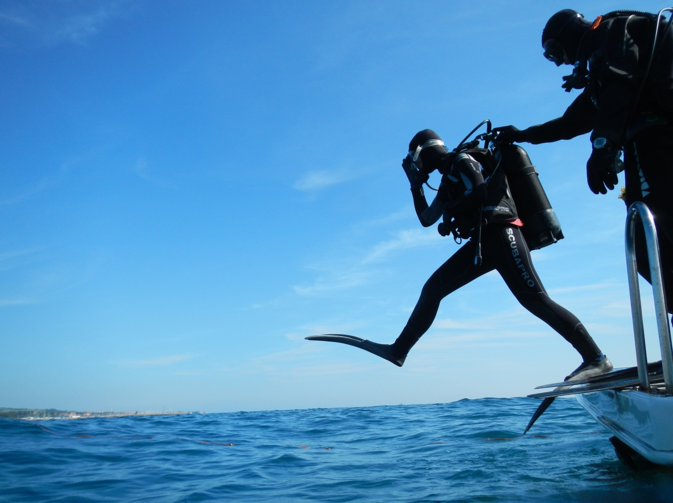
COME DIVING WITH US
NAUI AND COURSE INSTRUCTOR KEN McCRACKEN EMPHASIZE THOROUGH AND EXCELLENT INSTRUCTION THAT IS SAFE AND FUN.
OUR COURSE BEGINNING IN MAY AT THE BATTERY CREEK POOL
Saturday, May 7 6 – 9 pm (ZOOM class at home)
Tuesday, May 17 4 – 7 pm (pool), 8 – 9:30 pm (ZOOM class at home)
Thursday, May 19 4 – 7 pm (pool) 8 – 9:30 pm (ZOOM class at home)
Tuesday, May 24 4 – 7 pm (pool), 8 – 9:30 pm (ZOOM class at home)
Thursday, May 26 4 - 7 pm (pool), 8 – 9:30 pm (ZOOM at home)
Weekend, May 28 – 29 Open Water training dives or on one of our trips (We have a Fla. Kens dive May 31 – June 4)Course Cost and Requirements
Tuition is $325 OR $250 for household family member payable to the instructor (see below). This INCLUDES regulator with octo and gauges, buoyancy compensator, tank with airfills, weight belt and weights, and wetsuit.
$95 is payable to the instructor for textbook, online instruction, and certification.
Students need to provide their own mask, snorkel, boots, and fins that are adequate for ocean diving. It is recommended that students purchase this equipment from a reputable dive shop. This equipment is needed by the first pool session May 17. The instructor does not make a commission from equipment sales but can help guide students. The Scooba Shack in Savannah provides expert advice and a 10% discount for our students. Call them at (912) 660-7458 to make an appointment. $150 OR $100 for each additional household family member is payable for Open Water Training Dives EXCEPT $50 payable or zero for family members for Open Water training on one of our trips.
Students must be able to swim 150 meters and tread water 10 minutes using mask, snorkel, and fins AFTER instruction during the first class. A full refund will be provided to anyone who can't pass this test or who should not dive due to medical history.Registration and Information: SMALL CLASSES SO PLEASE DON’T DELAY
Register with Ken by phone or email shown below.
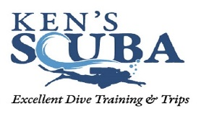
For questions, contact Ken McCracken, NAUI Professional Dive Educator, at (970)319-5747 or ken@kensscuba.com.
Once you are certified, keep diving. We have continuing education courses and trips, such as:
dive trips to Southern California , Florida Keys, and Bimini, Bahamas.

